Sri Lanka Institute of Information

Technology



Lab Submission

<Lab sheet No 07>

**<IT24102242>**

**<venura kithpura>**

**Discrete Mathematics | IT1160**

B.Sc. (Hons) in Information Technology

Exercise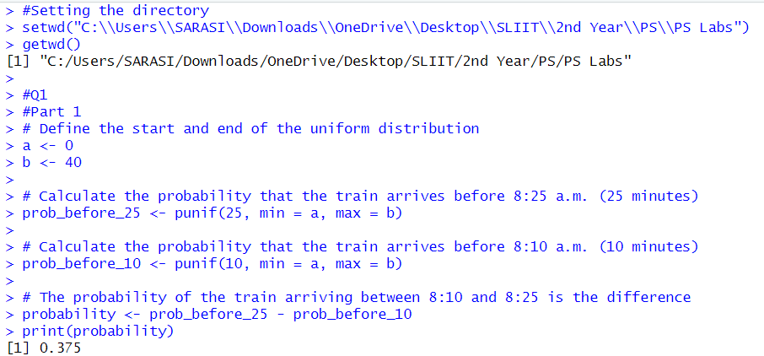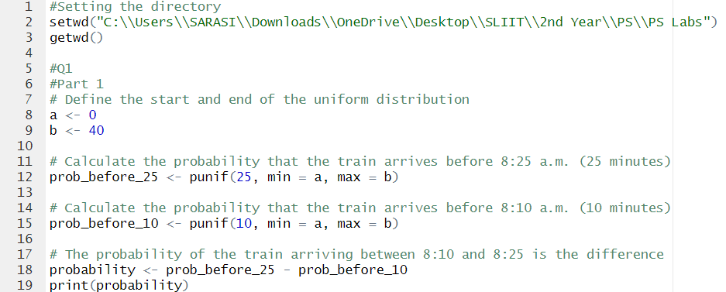

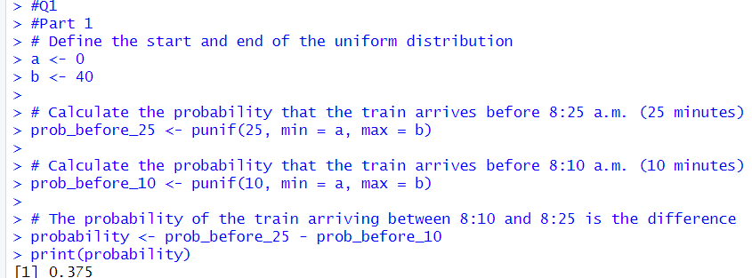Q1) 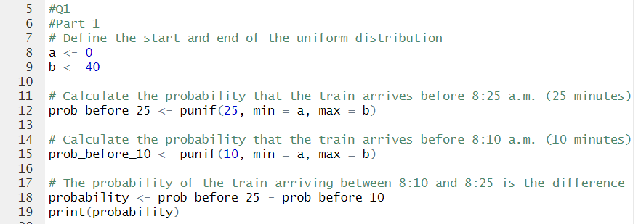

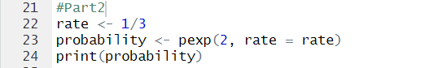Q2)

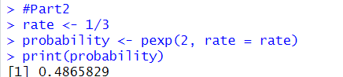

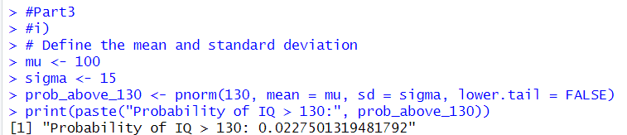Q3) i) 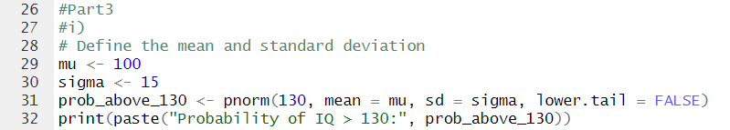

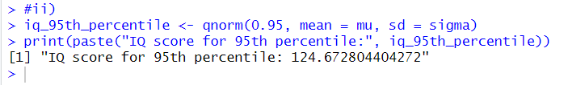ii) 